Test Summary Report
Project: <Project Name>
COMPANY: <VOLO>

Report Date : < 24/4/2018 >

Contents
Contents
Contents 2
1. Purpose 3
2. Application Overview 3
3. Testing Scope 3
4. Metrics 4
5. Types of testing performed 6
6. Test Environment & Tools 6
7. Recommendations 7
8. Exit Criteria 8
9. Conclusion 8
10. References 8

Purpose
This document explains the various activities performed as part of Testing of ‘ABCD transport system’ application.

Application Overview
‘ABCD transport system’ is a web based Bus ticket booking application. Tickets for various buses can be booked using the online facilities. Real time passenger information is received from a ‘Central repository system’, which will be referred before booking is confirmed. There are several modules like Registration, Booking, Payment and Reports which are integrated to fulfill the purpose.

Testing Scope
<This section explains about the functions/modules in scope & out of scope for testing; Any items which are not tested due to any constraints/dependencies/restrictions.
Example: A functionality verification which needs connectivity to a third party application cannot be tested, as the connectivity could not be established due to some technical limitations. This section should be clearly documented, else it will be assumed that Testing covered all areas of the application>

    - In Scope
Functional Testing for the following modules are in Scope of Testing
      - Registration
      - Booking
      - Payment
    - Out of Scope
API Testing was not done for this application.
    - Items not tested
Verification of connectivity with the third party system ‘Central repository system’ was not tested, as the connectivity could not be established due to some technical limitations. This can be verified during UAT (User Acceptance Testing) where the connectivity is available or can be established.

Metrics
<Metrics will help to understand the test execution results, status of test cases & defects etc. Required Metrics can be added as necessary. Example: Defect Summary-Severity wise; Defect Distribution-Function/Module wise; Defect Ageing etc.. Charts/Graphs can be attached for better visual representation>

a) No. of test cases planned vs executed
b) No. of test cases passed/failed

Test cases  planned | Test cases  executed | TCs  Pass | Tcs  Failed
80 | 75 | 70 | 5

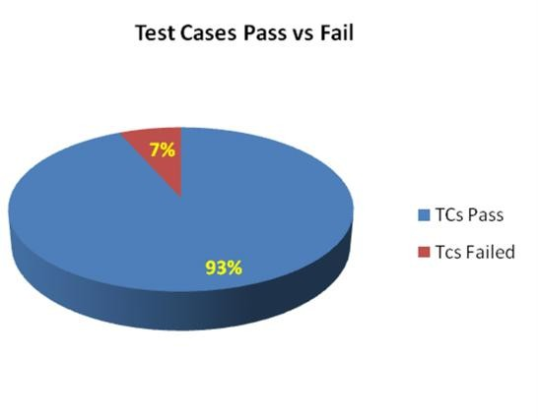

- No of defects identified and their Status & Severity

 | Critical | Major | Medium | Cosmetic | Total
Closed | 25 | 15 | 20 | 0 | 60
Open | 0 | 0 | 0 | 5 | 5
 |  |  |  |  | 65

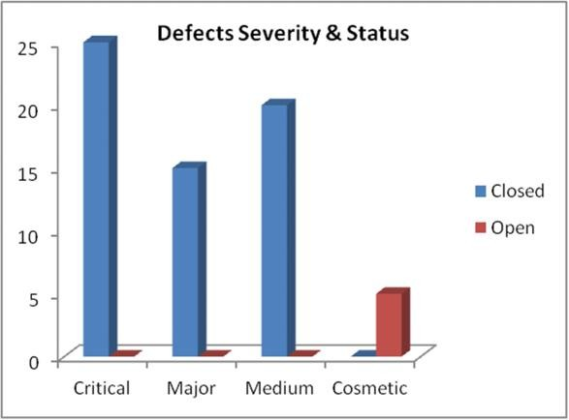

- Defects distribution – module wise

 | Registration | Booking | Payment | Reports | Total
Critical | 6 | 7 | 5 | 7 | 25
Major | 4 | 5 | 2 | 4 | 15
Medium | 6 | 8 | 2 | 4 | 20
Cosmetic | 1 | 2 | 1 | 1 | 5
Total--> | 17 | 22 | 10 | 16 | 65
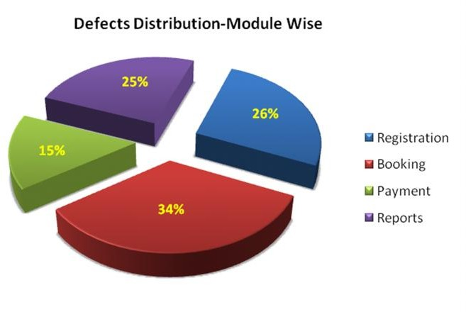

Types of testing performed
    - Functional testing
This type of testing ignores the internal parts and focuses only on the output to check if it is as per the requirement or not. It is a Black-box type testing geared to the functional requirements of an application.

    - Non Functional testing
It is a type of testing for which every organization having a separate team which usually called as Non-Functional Test (NFT) team or Performance team.
Non-functional testing involves testing of non-functional requirements such as Load Testing, Stress Testing, Security, Volume, Recovery Testing etc.
    - Performance testing
This term is often used interchangeably with ‘stress' and ‘load' testing. Performance Testing is done to check whether the system meets the performance requirements. Different performance and load tools are used to do this testing.

    - Security testing
Security Testing is done to check how the software or application or website is secure from internal and external threats. This testing includes how much software is secure from the malicious program, viruses and how secure and strong the authorization and authentication processes are.

Test Environment & Tools
<Provide details on Test Environment in which the Testing is carried out. Server, Database, Application URL etc. If any Tools were used like Quality Center (now HP ALM) for logging defects>

Application URL | http://abcd.2345.com
Apps Server | 192.168.xxx.22
Database | Oracle 12g
HP QC/ALM | 192.168.xxx.22

Recommendations
<Any workaround or suggestions can be mentioned here.>
- Admin control for defect management tool can be given to Offshore Test lead/manager for providing access to Testing team.
- Each time the onsite Admin need not be contacted for requests whenever they arise, thereby saving time due to the geographical time zone difference.

Exit Criteria
<Exit Criteria is defined as a Completion of Testing by fulfilling certain conditions>
    - All test cases should be executed – Yes
    - All defects in Critical, Major, Medium severity should be verified and closed – Yes.
    - Any open defects in trivial severity – Action plan prepared with expected dates of closure.
Example: No Severity1 defects should be ‘OPEN’; Only 2 Severity2 defects should be ‘OPEN’; Only 4 Severity3 defects should be ‘OPEN’. Note: This may vary from project to project. Plan of Action for the Open defects should be clearly mentioned with details on when & how they will be addressed and closed.>

Conclusion
<This section will mention whether the Testing team agrees and gives a Green signal for the application to ‘Go Live’ or not, after the Exit Criteria was met. If the application does not meet the Exit Criteria, then it can be mentioned as – “The application is not suggested to ‘Go Live’. In this scenario, It will be left with the decision of Senior Management and Client and other Stakeholders involved to take the call on whether the application can ‘Go Live’ or not.>
As the Exit criteria was met and satisfied as mentioned in Section 10, this application is suggested to ‘Go Live’ by the Testing team. Appropriate User/Business acceptance testing should be performed before ‘Go Live’.

References
<This section will include reference documentations, links, etc.>

